EE3060 Probability – Proposed questions and answers

Question 1:

From families with three children, a child is selected at random and found to be a girl. What is the probability that she has an older sister? Assume that in a three-child family all sex distributions are equally probable.

Answer 1:

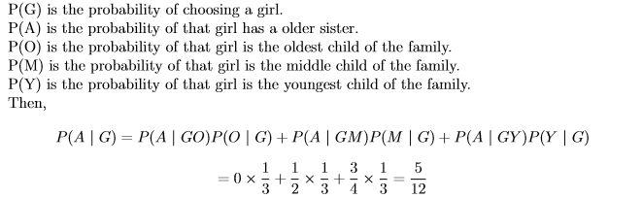

Question 2:

Assume that there are five bulb factory, the A factory will come out five broken products every hundred of bulbs , the B factory will come out four broken products every hundred of bulbs , the C factory will come out three broken products every hundred of bulbs , the D factory will come out two broken products every hundred of bulbs , the E factory will come out one broken products every hundred of bulbs. The market, which sells these bulbs , buys bulbs from these factories , but with different amount. (factory A : 100; factory B : 200; factory C : 300; factory D : 400; factory E : 500) If you bought a broken bulb today , what is the probability that it comes from factory A?

Answer 2:

Cause bulb broken or not and come from which factory are independent.

P(broken bulb): (5+4+3+2+1)/(100+200+300+400+500) = 15/1500 = 1%

P(bulb is from factory A | broken bulb) : [5/(5\*1+4\*2+3\*3+2\*4+1\*5)]\*0.01 / 0.01 = 5/38 ≈ 13%

Question 3:

random variable X with pmf p(X=i)=k\*(5t)i/i!

Calculate p(X=3)

Answer 3:

1. Sol k: ∑p(X=i)=k((5t)+(5t)2/2+(5t)3/3!…..)=k(e5t)

so k=e-5t

2.p(X=3)=e-5t\*6\*125t3

Question 4:

A monkey types on a 26-letter keyboard that has lowercase letters only. Each letter is chosen independently and uniformly at random from the alphabet. If the monkey types 1,000,000 letters. what is the expected number of times the sequence “ggqaq” appears?

Answer 4:

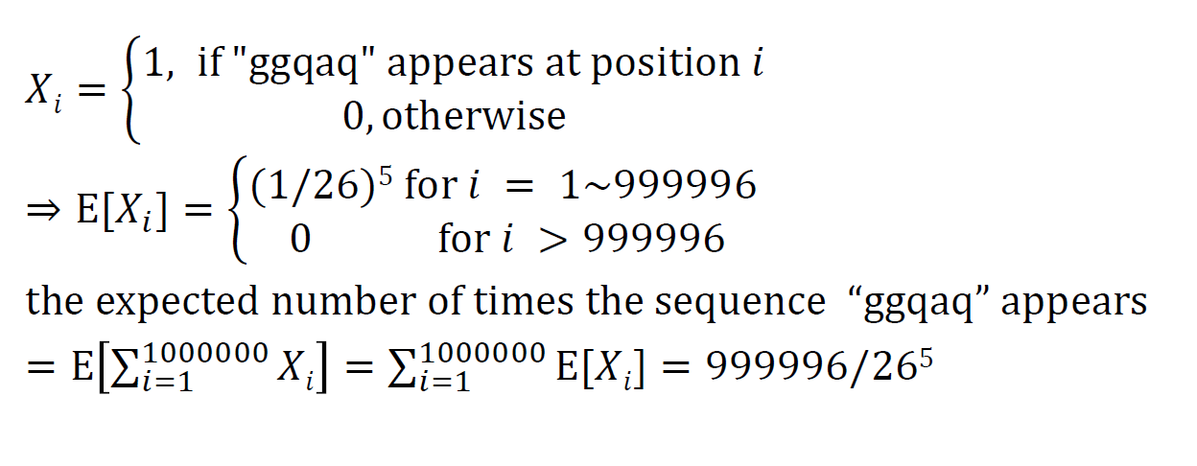

Question 5:

We draw cards uniformly at random with replacement from a deck of n cards. What is the expected number of cards we must draw until we have seen all n cards in the deck? If we draw k cards, what is the expected number of cards in the deck that are not chosen at all? Chosen exactly once?

Answer 5:

